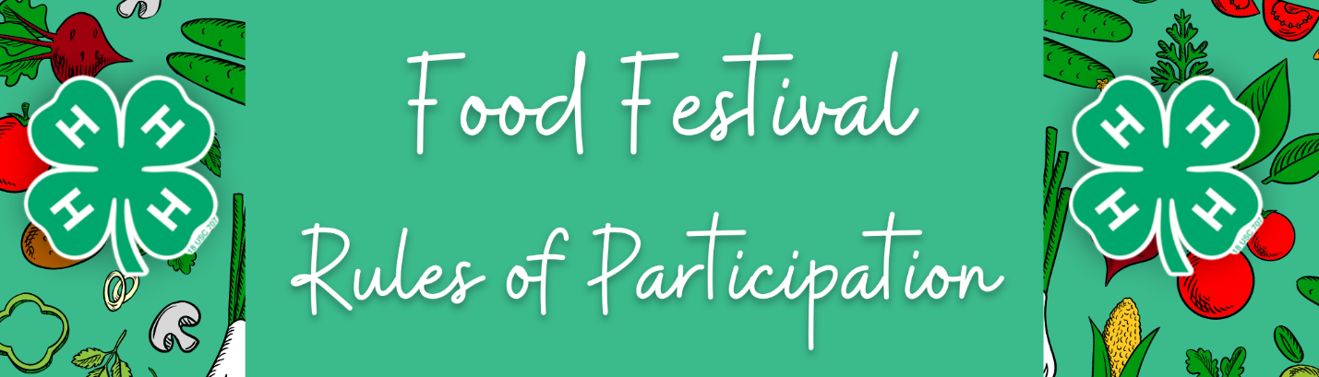

Guidelines for Food Festivals

- Please arrive 15 minutes earlier than your designated presentation time.
- Upon arrival at the Farm and Home Center please check in, remember your Food Festival Registration and Recipe Form.
- Each presenter will be given 10 minutes prior to their presentation for set up.
- Each presentation slot is 30 minutes long including evaluators feedback, so please plan your presentation accordingly.
- Once the presentation is complete our evaluator volunteers will move to another area to evaluate the next presentation. Each presenter will be given 10 minutes to clean up their area.

Rules of Participation

- There will be 2 divisions according to age:
Cloverbuds Time Allowed
5-7 years old as of January 1, 2024 Maximum 15 minutes

Juniors/Seniors Time Allowed
8-19 years old as of January 1, 2024 15-30 minutes

- Everyone must use at least one ingredient that is produced in New York. Examples include fruit, vegetables, grains, milk products, meat, eggs, honey, and maple syrup.
- The measuring of at least 1 dry ingredient and 1 wet ingredient must be correctly demonstrated; all other ingredients may be pre-measured.
- Each participant will be provided with a 2 ring electric burner if required.
- Entrants must bring all the ingredients and materials that they need for their demonstration, for example: ingredients, bowls, spoons, chopping board, knives, cook tops and serving plates.
- Ingredient brand names must be hidden by covering or transferring them to unmarked containers. EXCEPT for the NYS ingredient which may be labelled.
- All participants must give their completed Entry Forms in a plastic envelope to the evaluators.
- Cloverbuds must include a picture they have drawn of their dish, or a photo they have taken of them with a practice dish they made at home – it must clearly show the finished dish.
- Juniors/seniors must include a menu card for a meal, with their recipe as one of the courses.
- Each participant should bring some to share, as well as recipe cards for others to take home.
- Arriving late for your time may result in being unable to participate.

NOTE: Youth who wish to have their demonstrations count as their public presentation MUST speak throughout the presentation.

Registration Reminders
- Participants must be actively enrolled 4-H members/Cloverbuds to participate.
- Read the rules and study the appropriate evaluation rubric.
- Be sure all entry forms are complete, and include required pictures or menu cards.
- Be sure to bring some to share and recipe cards for people to take!
- Practice, practice, practice!

