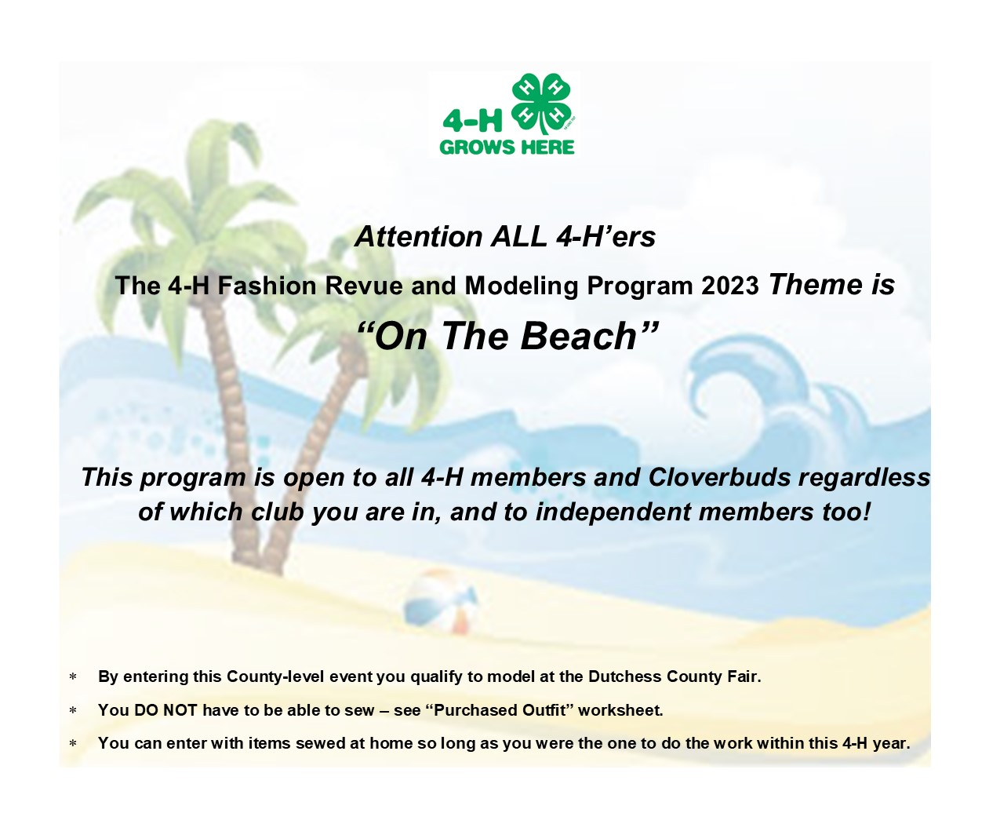

Conditions:
- Submit entries on time with all paperwork completed
- Attend the evaluations at CCEDC starting 6pm
- Participate in the Fashion Review at CCEDC starting 6pm
- Youth are then eligible to exhibit at the Dutchess County Fair

Thursday April 13: Entries Close
Email entries (worksheet & commentary) to Mary at mem547@cornell.edu or mail, or hand deliver for Mary’s attention to arrive by 4/13/23

Thursday April 20: Sewing and Project Evaluations
Evaluation Evening and Modelling Practice (must attend this to qualify for Fashion Revue). Commentaries will be reviewed and finalized and must be submitted at this event to qualify for Fashion Revue)

Thursday April 27: 4-H Fashion Review
Dutchess County 4-H Fashion Revue: a fashion show featuring catwalk modelling, celebration and awards.

4-H Fashion Revue Program 2023

THE RULES
- All 4-H’ers and Cloverbuds in any program area or as an Independent Member may enter the Evaluations and Fashion Revue.
- To take part in the Fashion Revue, youth must enter on time and attend the Evaluation Evening (see dates above).
- Those who attend both events successfully and are in good standing in 4-H qualify to model at the Dutchess County Fair!
- Member’s projects should be age/skill appropriate and should meet all criteria on the relevant evaluation sheet.
- Each entry must be accompanied by the relevant worksheet.
- Participants who choose to sew must sew their own garments but are allowed some help where appropriate. (i.e., younger members, new skills, etc.).
- Participants who choose to purchase an outfit are encouraged to set a budget before purchasing items and should aim to stay within the budget for items that are good value and high quality. Consider checking out thrift stores!
- All participants must write their own commentary (Cloverbuds may have help) and type it up as detailed in the guide.
- The sewing projects for this program must be garments; however, accessories may be added for effect and can be entered in the relevant Fair class.
- Sewed garments can be made from scratch or can be entered in the ‘recycled’ class where existing items have been repurposed into new items of clothing.
- 4-H members participating in Fashion Revue will be evaluated on their modeling and Cloverbuds will be given feedback to help them improve their skills.
- Any member who receives a blue award on Evaluation Night can enter their project at the Dutchess County Fair and not have to be re-evaluated provided that a copy of the evaluation form is attached in addition to an EIS card.
- Any member receiving a red or white award may work on improving their item and enter it at the Fair to be re-evaluated.
- Any member 13 years and older who receives a blue ribbon on both their garment and modeling could be eligible for State Fair.

EVALUATION NIGHT
- Participants must submit fully completed entry forms in a timely fashion.
- Attendance at evaluation night is required to proceed to Fashion Revue.
- Participants should bring their whole outfits and props, including their sewn garment if applicable, to Evaluation Night.
- Participants will explain their project to the evaluator and answer questions.
- All Cloverbud exhibitors will be given helpful feedback in person by evaluators.
- Youth will have an opportunity to practice modeling while using their props.
- Commentaries will be reviewed and adjusted if needed.

WHAT TO BRING TO EVALUATION NIGHT – applies to ALL Participants
- Everything that you will need for the Fashion Show so you can practice.
- Change of clothes - Allow time to change before your pre-assigned time. After the modeling practice and initial evaluations, change into regular clothes to allow evaluators to look closely at garments.
- Original Patterns – For sewn garments, evaluators will need to see the pattern to evaluate how well it was followed or changes that were made.
- Project Worksheets - Worksheets should be completed and ready to be turned into the evaluator on arrival for both sewn and purchased garments.
- Commentary – Each participant must write a commentary which will be read as they model. Keep a copy. It must comply with the guidelines below.

WHAT TO BRING TO THE FASHION REVUE
- Everything detailed above with any changes/improvements suggested at evaluation night.
- Arrive at least 30 minutes before the show is due to start.
- Families may be asked to bring refreshments to share.
- Invite other 4-H’ers, family and friends.
- Come prepared to have fun!

SET UP AND TAKE DOWN
Setting up the stage, decorating, then tidying everything away afterwards takes a lot of work. Set up is usually done the evening beforehand. Take down can happen the same evening as the fashion show once it is over. Please volunteer to help with this if you can! Reach out to your Club Leaders or the 4-H office if you can help.

