Name

Club
Section 2: Project Record
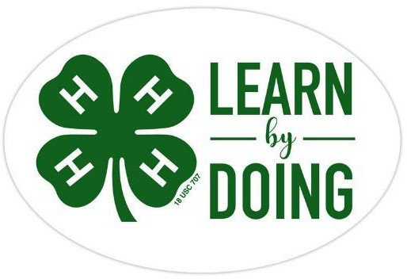

Llama & Alpaca
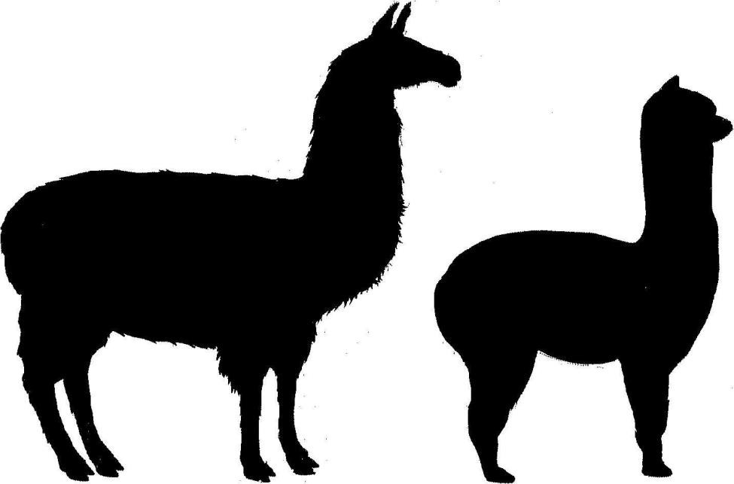

CCEDC is an employer and educator recognized for valuing AA/EEO, Protected Veterans, and Individuals with Disabilities and provides equal program and employment opportunities. The programs provided by this agency are partially funded by monies received from the County of Dutchess. Please contact the CCEDC office if you have any special needs.

DUTCHESS COUNTY 4-H LLAMA ALPACA PROJECT

PROJECT OBJECTIVES:
The purpose of the project is to help 4-H Club members to:
- Gain knowledge and skill in the principles of animal selection, breeding, feeding,management, fitting and showing, marketing, record keeping, and business.
- Promote and develop leadership and desirable traits of character.
- Develop a greater love of llamas and alpacas and experience ownership.
- Prepare for the future by developing leaders and responsible citizens.

REQUIREMENTS:
- Be an enrolled member of a 4-H Club or an Independent Member.
- Attend meetings regularly according to project/club bylaws.
- Follow the leadership of the Project Leaders and Extension Staff.
- Conduct a llama or alpaca project.
- Complete a County Level Public Presentation, participate in Community Service, and keep an accurate and up to date 4-H Record Book.

DETAILS OF YOUR PROJECT LLAMA

Name: Date of Birth:

Sex: Color:

Height: Weight:

Identification: Registration #:

Sire: Dam:

Date Acquired: Bred Purchased Sponsored

Details on owner if sponsored:
.
Check one of the above

Insert a picture of your llama here– Include a caption above

DETAILS OF YOUR PROJECT ALPACA

Name: Date of Birth:

Sex: Color:

Height: Weight:

Identification: Registration #:

Sire: Dam:

Date Acquired: Bred Purchased Sponsored

Details on owner if sponsored:
.
Check one of the above

Insert a picture of your alpaca here– Include a caption above

SHOW RECORDS

Give details below of each show and each class you participate in during the year

Show | Class | # Entries | Placing
Tell us about what you learned from showing, the things you enjoy about it, and the things you found challenging or difficult.

PROJECT EXPENSES
Please record all expenses for your project. These may include feed, veterinarianfees, show entries, equipment, etc.

Date | Description of Item or Service | Cost
 | TOTAL:

PROJECT INCOME
Please record all income received from or related to your project.

Date | Description of Item or Service | Cost
 | TOTAL
Using the two totals above, calculate what you spent or earned from your project this year.

FINAL TOTAL:

15

Project Information Worksheet
A project is a sequence of tasks that must be completed to get to the outcome you have chosen. Projects have a definite beginning, which starts with planning them. They have a definite end which is when you complete them.

Title of your chosen project
Date of project start Date of project end Describe your project

Explain what you learned as a result of this project

What would you do differently if you were going to do this project again in the future?

16

Financial Summary of Project
There is a cost to every project. Costs include things such as time spent on the project, travel to shop for materials, and the things you purchase to complete the project. For every project, you should consider if the outcome was worth what it cost.
In total, how many hours did you spend on this project (at home and at meetings) Did your parents have to drive you to get materials YES NO Cost of the Project Materials
Complete the table below in as must detail as possible to include ALL the materials that were used in your project. Then, add up the costs for a total tally.

Purchase Date | Detailed Description of Items Purchased Include where from, what for and cost per item | Cost
Example
11.20.2021 | Eggs from Hackett’s to make pancakes for the Harvest Food Festival. 12 eggs cost $4.00. I used 3 eggs | $1.00

Total Project Cost
$

17

Project Information Worksheet
A project is a sequence of tasks that must be completed to get to the outcome you have chosen. Projects have a definite beginning, which starts with planning them. They have a definite end which is when you complete them.

Title of your chosen project
Date of project start Date of project end Describe your project

Explain what you learned as a result of this project

What would you do differently if you were going to do this project again in the future?

18

Financial Summary of Project
There is a cost to every project. Costs include things such as time spent on the project, travel to shop for materials, and the things you purchase to complete the project. For every project, you should consider if the outcome was worth what it cost.
In total, how many hours did you spend on this project (at home and at meetings) Did your parents have to drive you to get materials YES NO Cost of the Project Materials
Complete the table below in as must detail as possible to include ALL the materials that were used in your project. Then, add up the costs for a total tally.

Purchase Date | Detailed Description of Items Purchased Include where from, what for and cost per item | Cost
Example
01.20.2022 | 4 yards of cotton print fabric form JoAnn Fabrics to make my summer skirt. Cost $7 per yard + tax | $30.31

Total Project Cost
$

YEAR IN REVIEW
Specific to your project, answer the following questions. Please add drawings, pictures, diagrams, or newspaper clippings.
What were your goal(s) for this year?

Did you achieve them? Explain why or why not.

What was your greatest accomplishment this year?

What do you want to work on or learn about next year?

YEAR IN REVIEW continued
Use this space to add additional feedback on your project this year.

Summary of Club Meetings attended in the current 4-H Year
This record is of business meetings and educational activities done as a club. It does not include special events such as countywide events, field trips, shows, the fair, etc.

Club Name: Club Leader(s)

Club meetings attended this year | # Meetings held by Club | # Meetings you attended | % Meetings you attended | # Hours you attended
A minimum of 6 meetings per year is required by all clubs. What percentage attendance is required by your club? %

Summary and Declaration
Those youth completing all 4-H expectations will be deemed as being in “GOOD STANDING” for the current 4-H year. This is an accomplishment to be proud of and will be rewarded with a Certificate and 4-H Achievement Pin.

Complete the table below to be eligible for this award by checking the box to certify you fulfilled each expectation.

4-H Expectations to complete the 4-H Year in GOOD STANDING | State YES if you completed  this
Enrolled in 4-H by May 31 of the current 4-H year
Always abided by the 4-H Code of Conduct
Attended at least the minimum number of meetings required by my club(s)
Met all 4-H and Club deadlines on time
Completed a County-level Public Presentation
Submitted MY 4-H Story in the correct format on time
Submitted my completed Project Record Book on time
I hereby declare that this 4-H Record Book, which contains:
- Section 1: My Personal Development Record
- Section 2: My Project(s) Record(s)

This is a true record of my activities/accomplishments from the current 4-H year. I confirm that, so far as is reasonably possible given my age and abilities, it is my own work.
Signed by 4-H’er: Signed by Club Leader:

