4-H Personal Development

Year:

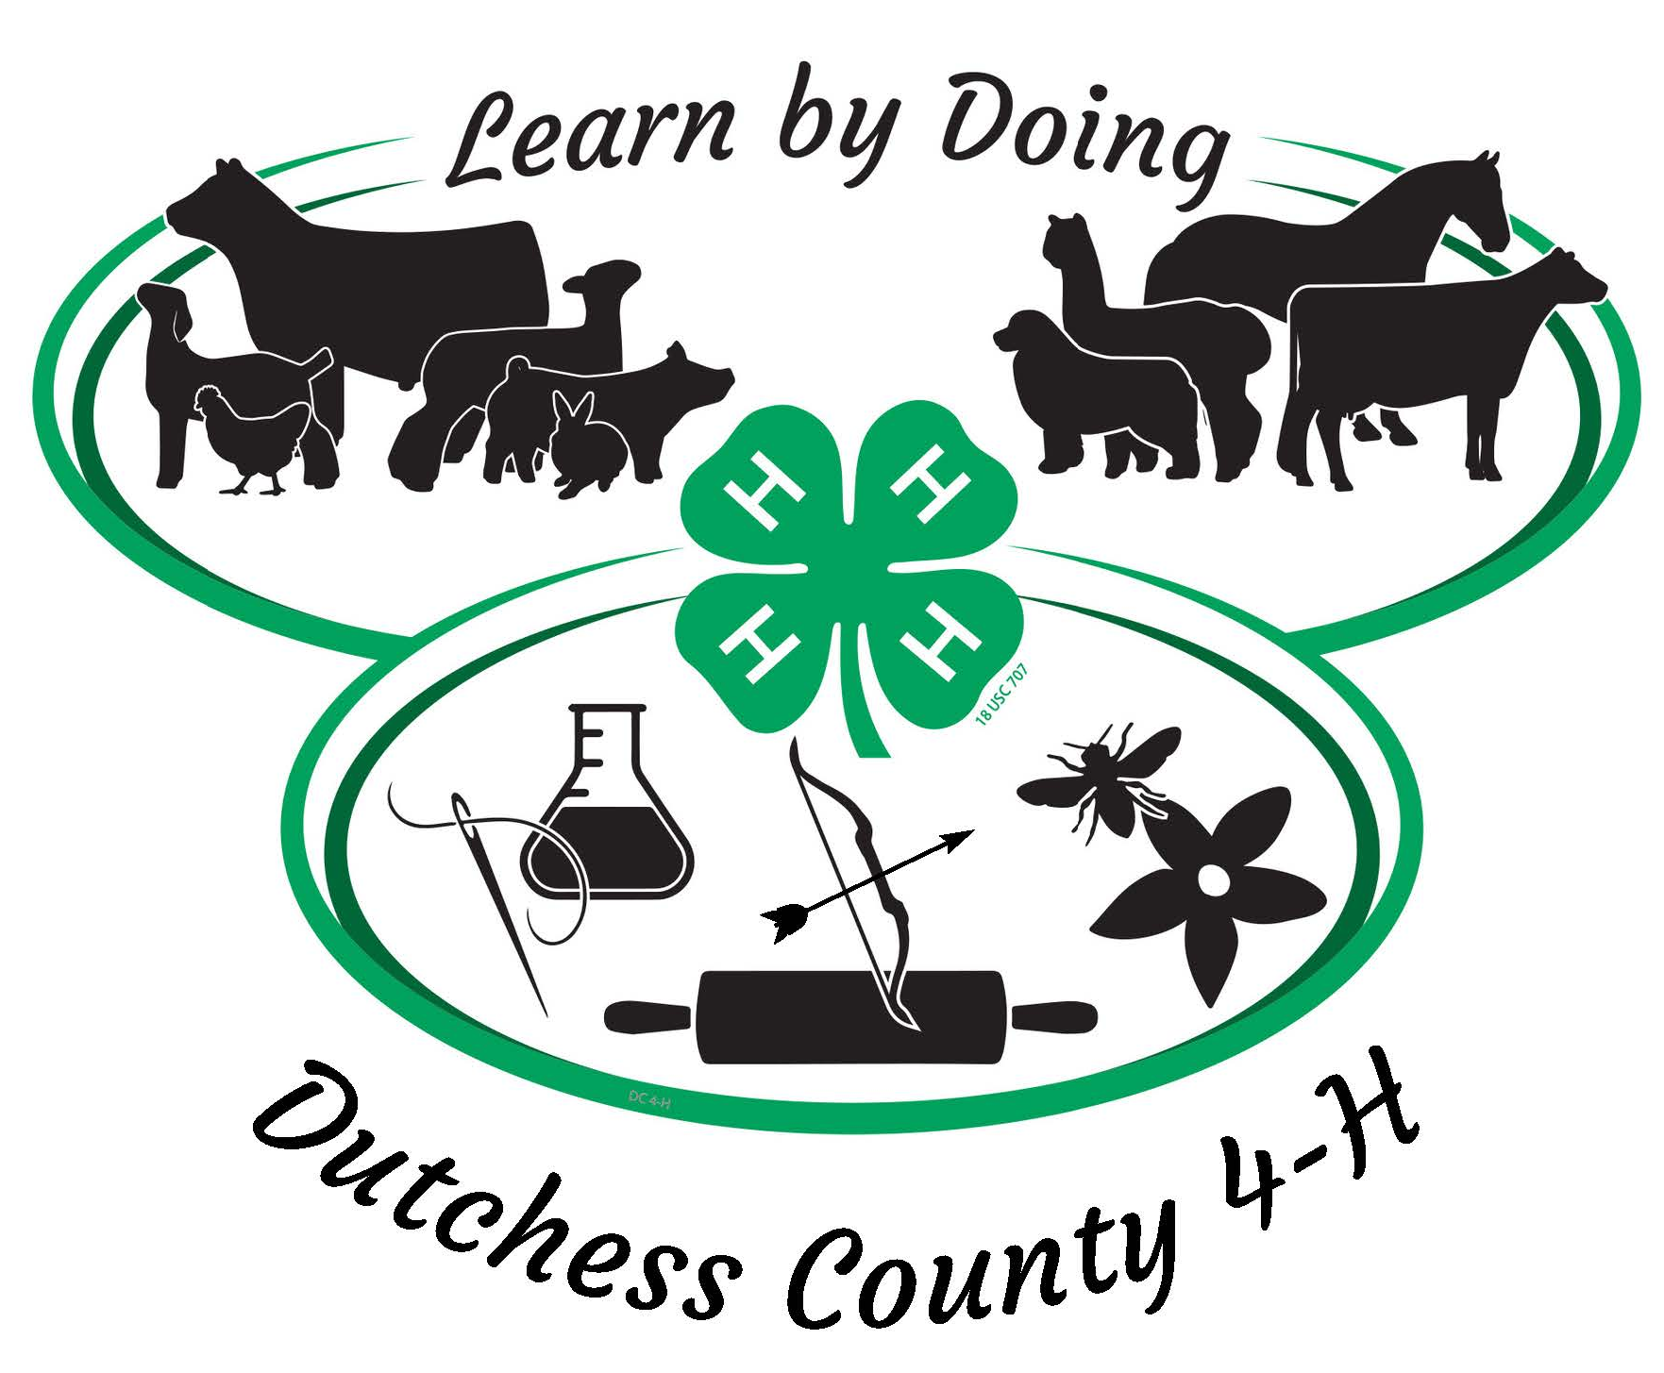

For 4-H Members aged 8 and upwards

Name of 4-H’er: 4-H Age:

Club(s)

and/or
Independent
Projects:

4-H Record Book Information

Important Details
- Complete 4-H Record Book must include 4-H Personal Development (this section) and sections for each project you have participated in this year
- Record Books must be received by the 4-H Office by September 30th of the current 4-H year
- They can be submitted either as a hard copy in a binder, or by uploading your complete electronic record book here as a PDF file 4-H Record Books 2022-23; you must use one or the other method – not a combination!
- For the Project Section(s) consult your Leaders
- Youth not submitting an adequately completed 4-H Record Book (appropriate to age and abilities) may not be eligible for re-enrollment the following year
- Great prizes and certificates for the best Record Books in each project area

Section 1: Personal Development Record (this section)
- Written by the 4-H Office, this will be used for funding purposes and must be completed as failing to do so jeopardizes the program for all 4-H’ers
- Provides a summary of your achievements including reports on meetings, 4-H activities, accomplishments, and community service
- Each youth must complete their ‘My 4-H Story’ – see below

Section 2: Project Record
- Designed by each Project Advisory (your Club Leaders) to enable youth to demonstrate project-specific knowledge and learning
  - This section will be checked on an ongoing basis by relevant Club Leaders or designated volunteers
  - Must be up to date by August 1 if 4-H’er wants to exhibit at the Fair

Why Keep Record Books
- 4-H helps young people succeed in the ‘real world’ and, by doing Record Books

with the support of parents and Leaders, 4-H’ers can:
  - Develop good habits such as keeping up-to-date records
  - Improve literacy skills
  - Showcase achievements
  - Express themselves by creating a ‘journal’ to reflect on and be proud of
- 4-H Record Books have a lot of practical uses such as:
  - Supplementing school portfolios when applying for colleges and jobs
  - Serving as proof to 4-H funders that the kids are benefitting and learning from the program
  - Being entered into the Fair and winning end-of year awards

Section 1: Personal Development Record

Include a photograph of yourself here

Add a caption for your photograph here

Introduce Yourself Share details of yourself, your hobbies, interests, and ambitions, where you go to school, your family, and any other facts it would be of interest for the reader to know.

Public Presentations
Provide details of the Public Presentation(s) you completed this year. Include your certificate if possible

Date you completed a County Public Presentation this 4-H year

Complete the following:

Check to indicate the type of presentation you completed:

Food Festival Demo Demonstration/Illustrated Talk Interview

Speech Horse Communications Other

Title of your Presentation

Explain why you chose this topic and/or style of presentation

Check to indicate what level of award you received

Purple Blue Red White

Explain what you learned from doing the presentation and how this might help you in future situations, e.g., at school, college, or work

Community Service and Citizenship
Provide details of activities you have participated in through 4-H to help the 4-H program, any other non-profit, or people/animals in your town, county, country, or the world lead happier, healthier lives.

Date | Location | Hours you spent | Who was helped
Use the space below to describe what you did, how it made you feel, and why community service is important

Other 4-H Responsibilities, Events and Activities
Complete the following table as you go through the year. Include all 4-H related events and activities NOT covered above or in your Project Record Book. Examples include but are not limited to:
- Leadership activities such as Club Officer, mentoring others and Teen Ambassador activities
- District and State-level events such as presentations and competitions
- Career development such as attending conferences and trainings
- Educational activities such as field trips and short programs
- Scholarships or special recognition awards

Date | Description | What you learned

My 4-H Story is your personal story that sums up this year in 4-H
Things you MUST write about are:
- Why you enrolled in 4-H this year
- A clear description of what your goals were in each project area
- How and why you achieved your goals, exceeded them, could not meet them, overcame challenges
- Your successes and accomplishments
- Examples of what you learned as a person (life skills) and through your projects (vocational skills)
Things you might include are:
- Funny moments and good memories, and friends you made along the way
- How you helped others through Community Service
- Up to 3 photos or pictures relevant to the story

4-H Story Guidelines
The quality of the story is the most important part. Categories excluding pictures:
- Cloverbuds (5-7 or those with special needs): words/pictures appropriate to abilities
- Junior (9-11) 250 words minimum (approximately 1 page)
- Intermediate (12-14) 400 words minimum (approximately 2 pages)
- Senior (15-19) 600 words minimum (approximately 3 pages)

- Cloverbud stories should be submitted as a hand-written document
- Others can be hand-written or, if typed in Word or Google Docs:
  - Double spaced, 12-point text, serif font such as Times New Roman
- All should use age/ability-appropriate vocabulary, grammar, and spelling

Why Write Your 4-H Story
- Looking back and reflecting helps us evaluate our strengths and limitations, understand ourselves better, appreciate our accomplishments and set goals for the future
- Expressing our thoughts in writing is essential to achieving many other things in life such as a place at college or a job - but it takes practice
- Those who make the 4-H program possible such as our funders want to read your stories - it motivates them to continue to support you

What 4-H Will do with Your Story (with your permission)
- All stories will be read by experienced volunteers/staff and receive feedback
- The three most powerful stories will be chosen from 4 categories:
- The chosen stories will have the honor of being published in the Annual 4-H Success Story Book which will be shared with stakeholders, and on our website
- The winners will receive gift certificates to the 4-H Mall and other goodies

MY PERSONAL 4-H STORY

by

Name Age

Write your story in the space below. Add additional pages if required

MY Personal 4-H STORY continued

