Section 2: Project Record
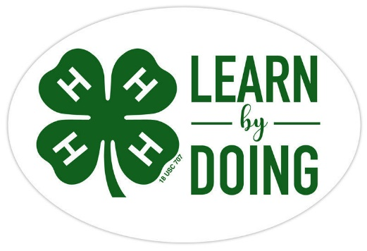

General Interest

Name

Club

CCEDC is an employer and educator recognized for valuing AA/EEO, Protected Veterans, and Individuals with Disabilities and provides equal program and employment opportunities. The programs provided by this agency are partially funded by monies received from the County of Dutchess. Please contact the CCEDC office if you have any special needs.
Photographs and Pictures
Add extra pages anywhere in your Record Book with more pictures! Please include at least two photos here showing us things you worked on this year. Give each photo a caption.
Insert photo here with caption below

Insert photo here with caption above
Business Meeting Reports
Keeping notes from meetings helps to remember what has been agreed and what is planned so you can meet responsibilities and deadlines. Complete the following reports after each of 4 of the official business meetings you attend.

Business Meeting #1

Meeting Date and Venue

Items Discussed (use bullet points)

Items Voted on and result of vote(s)

Explain some things you learned at this meeting

Business Meeting #2

Meeting Date and Venue

Items Discussed (use bullet points)

Items Voted on and result of vote(s)

Explain some things you learned at this meeting

Business Meeting #3

Meeting Date and Venue

Items Discussed (use bullet points)

Items Voted on and result of vote(s)

Explain some things you learned at this meeting

Business Meeting #4

Meeting Date and Venue

Items Discussed (use bullet points)

Items Voted on and result of vote(s)

Explain some things you learned at this meeting

Project Information Worksheet 1
A project is a sequence of tasks that must be completed to get to the outcome you have chosen. Projects have a definite beginning, which starts with planning them. They have a definite end which is when you complete them.

Title of your chosen project 1

Date of project start Date of project end

Describe your project

Explain what you learned as a result of this project

What would you do differently if you were going to do this project again in the future?

Financial Summary of Project 1
There is a cost to every project. Costs include things such as time spent on the project, travel to shop for materials, and the things you purchase to complete the project. For every project, you should consider if the outcome was worth what it cost.

In total, how many hours did you spend on this project (at home and at meetings)

Did your parents have to drive you to get materials YES NO

Cost of the Project Materials
Complete the table below in as must detail as possible to include ALL the materials that were used in your project. Then, add up the costs for a total tally.

Purchase Date | Detailed Description of Items Purchased  Include where from, what for and cost per item | Cost
Example
11.20.2021 | Eggs from Hackett’s to make pancakes for the Harvest Food Festival. 12 eggs cost $4.00. I used 3 eggs | $1.00
$
Total Project Cost

Project Information Worksheet 2
A project is a sequence of tasks that must be completed to get to the outcome you have chosen. Projects have a definite beginning, which starts with planning them. They have a definite end which is when you complete them.

Title of your chosen project 2

Date of project start Date of project end

Describe your project

Explain what you learned as a result of this project

What would you do differently if you were going to do this project again in the future?

Financial Summary of Project 2
There is a cost to every project. Costs include things such as time spent on the project, travel to shop for materials, and the things you purchase to complete the project. For every project, you should consider if the outcome was worth what it cost.

In total, how many hours did you spend on this project (at home and at meetings)

Did your parents have to drive you to get materials YES NO

Cost of the Project Materials
Complete the table below in as must detail as possible to include ALL the materials that were used in your project. Then, add up the costs for a total tally.

Purchase Date | Detailed Description of Items Purchased  Include where from, what for and cost per item | Cost
Example
01.20.2022 | 4 yards of cotton print fabric form JoAnn Fabrics to make my summer skirt. Cost $7 per yard + tax | $30.31
$
Total Project Cost

YEAR IN REVIEW
Specific to your project, answer the following questions. Please add drawings, pictures, diagrams, or newspaper clippings.

What were your goal(s) for this year?

Did you achieve them? Explain why or why not.

What was your greatest accomplishment this year?

What do you want to work on or learn about next year?

Summary of Club Meetings attended in the current 4-H Year
This record is of business meetings and educational activities done as a club. It does not include special events such as county events, field trips, shows, fashion review, the fair, etc.

Club Name:
Club meetings attended this year | # Meetings held by Club | # Meetings you attended | % Meetings you attended | # Hours you attended
A minimum of 6 meetings per year is required by all clubs. What percentage attendance is required
%
by your club?

Why you Joined This Club
Use the space below to tell us why you joined this club. Then give examples of some of the things you enjoyed most as they happen during the year.

Summary and Declaration

Those youth completing all 4-H expectations will be deemed as being in “GOOD STANDING” for the current 4-H year. This is an accomplishment to be proud of and will be rewarded with a Certificate and 4-H Achievement Pin.

Complete the table below to be eligible for this award by checking the box to certify you fulfilled each expectation.

4-H Expectations to complete the 4-H Year in  GOOD STANDING | State YES if you completed this

Enrolled in 4-H by May 31 of the current 4-H year

Always abided by the 4-H Code of Conduct

Attended at least the minimum number of meetings required by my club(s)

Met all 4-H and Club deadlines on time

Completed a County-level Public Presentation

Submitted MY 4-H Story in the correct format on time

Submitted my completed Project Record Book on time

I hereby declare that this 4-H Record Book, which contains:
Section 1: My Personal Development Record; and
Section 2: My Project(s) Record(s)
is a true record of my activities/accomplishments from the current 4-H year.

I confirm that, so far as is reasonably possible given my age and abilities, it is my own work.

Signed by 4-H’er:

Signed by Club Leader:

