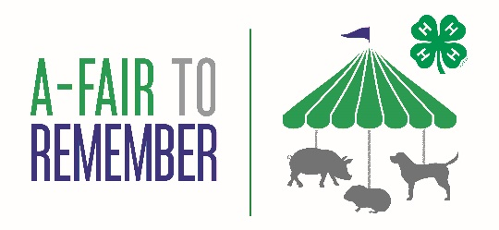
To be held on June 2nd, 2024
at
Wilcox Memorial Park, Rt. 199 Stanfordville
10am – 3:30pm
March 17th, 2024
To supporters of 4-H:
In 2022 and 2023 the 4-H A-Fair to Remember Gala Fundraiser was an incredible success. Not only did those who attended have a great experience, we achieved our goals in making the fair an inclusive event:
- 292 youth participants entered 1,864 classes at no cost
- 25 scholarships were provided to support families
- 62 immigrant/low-income family members were funded to attend
- Events such as a free family pasta dinner brought the community together

This year, our goals are just as high but we are changing the nature of the event to make it possible for more families in our community to experience the incredible work our 4-H youth do. In partnership with Dutchess County, we will be joining the team at Wilcox Park for the opening of their superb new splash pad. 4-H will have a dedicated area with event more activities, animals and opportunities to learn.

This is a free event and we will be relying on your generosity to help the kids help themselves. I hope you will support them in whatever way you can: sharing event details in your community, sponsoring and/or donating, and/or giving prizes for our event. Your support makes a difference, especially as we have the promise of matched funds, doubling up to $5,000 of personal donations!

Please visit our website to find out more. I look forward to another wonderful 4-H year and thank you for your support.
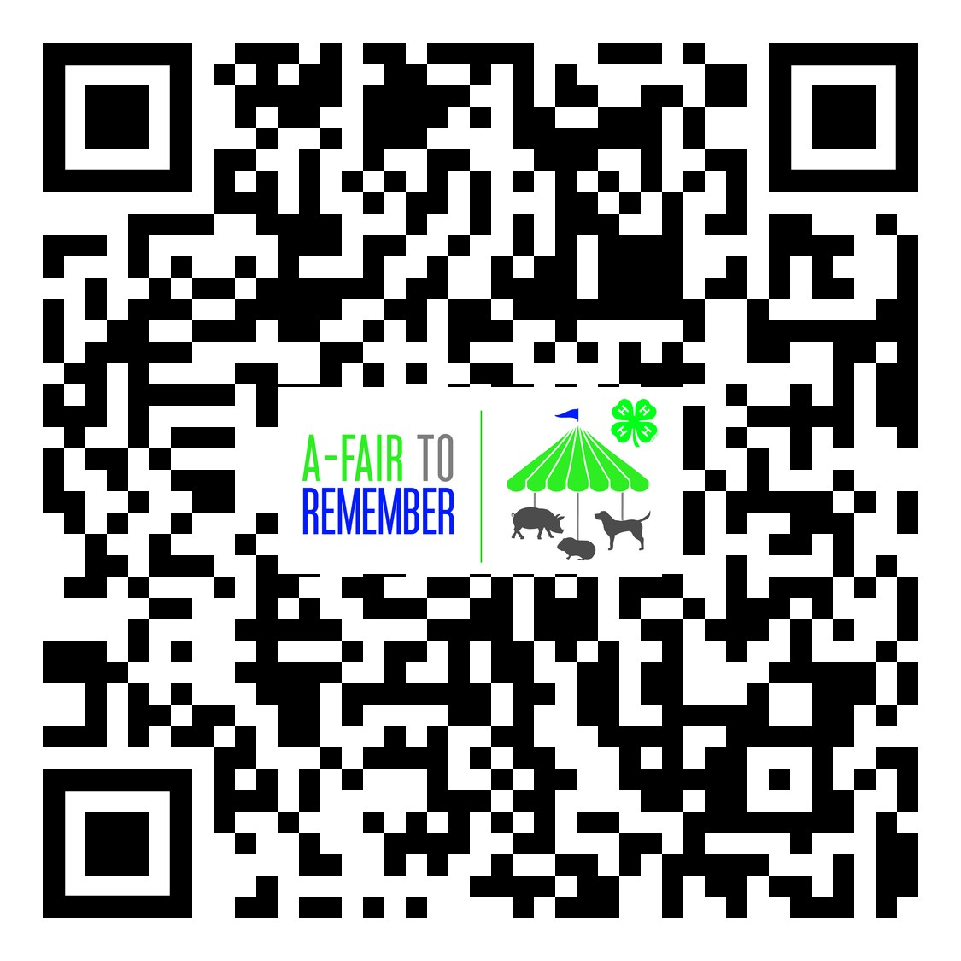
Very sincerely,

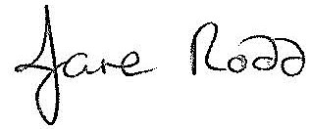

Jane Rodd: 4-H Program Leader
Email: jr827@cornell.edu
Help promote our event by copying and pasting this picture into your Facebook or Instagram feed!

