Ag Literacy Week: March 20th-24th, 2023

Name of School/Program: _______________________________________________________________
Name of Teacher: _________________________________________________________________________
Name of Reader (if different from teacher): ____________________________________________
Please record the number of youth participating in this program below:
1st Grade: ________________ 2nd Grade: _________________ 3rd Grade: _________________
Other: _____________________________
Please fill out the demographics for the total number of the youth participating:
Gender
Male: __________________ Female: __________________ Other: __________________
Race
Hispanic: __________________ Non-Hispanic: __________________
Ethnicity
White: __________________
White & Asian: __________________
White & Black: __________________
White & American Native/Alaskan Native: __________________
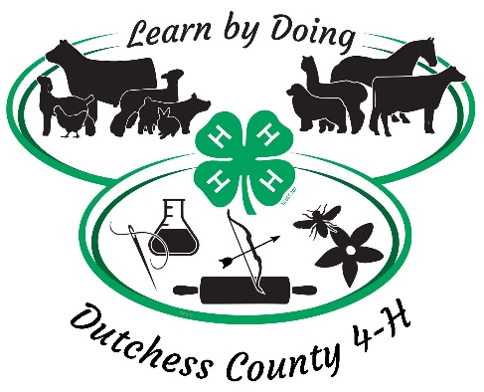
Asian: __________________
Asian & Black: __________________
Asian & American Native/Alaskan Native: __________________
Black: __________________
Black & American Native/Alaskan Native: __________________
Black Native Hawaiian: __________________
American Native/Alaskan Native: __________________
Other/Unknown: __________________

