4-H Personal Development

Year:

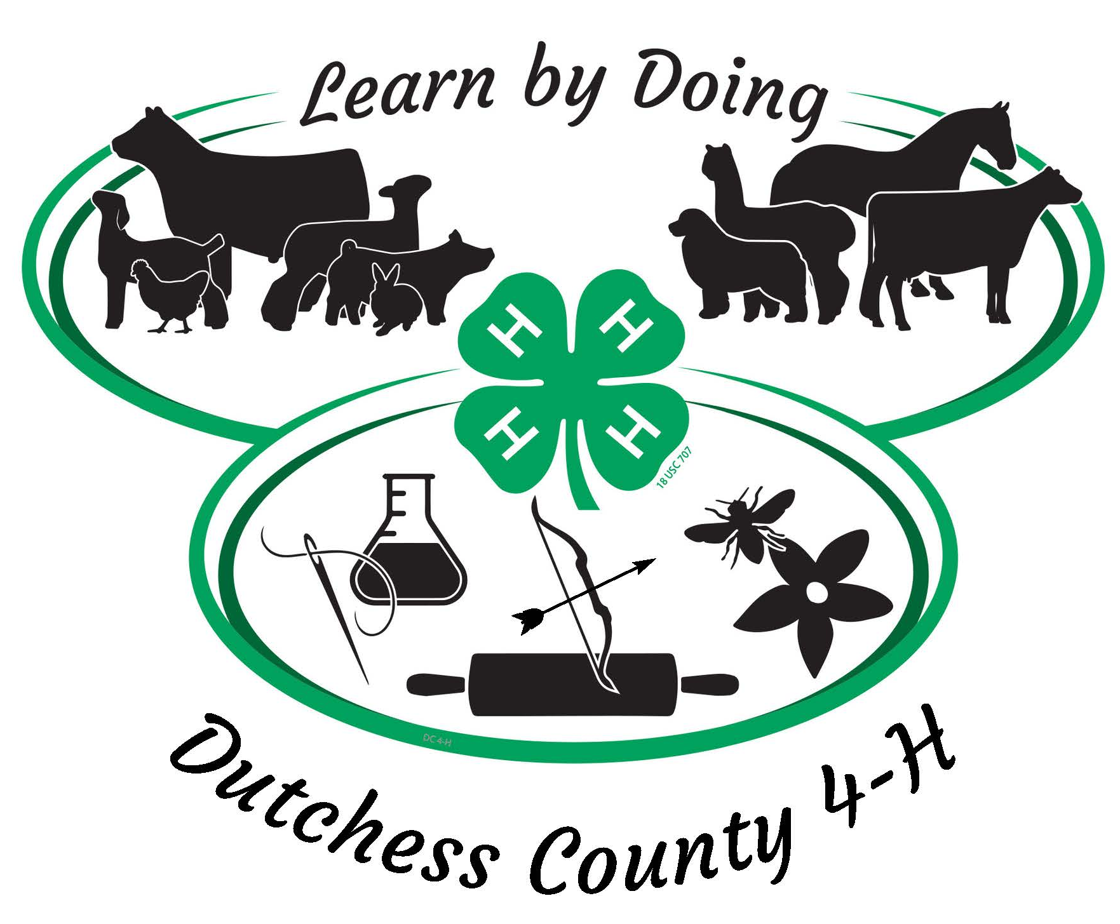

For 4-H Cloverbuds 5-7 years of age
and other youth needing accommodations

Name of 4-H’er: 4-H Age:

Club(s)

and/or
Independent
Projects:

4-H Record Book Information

Important Details
- Complete 4-H Record Book must include 4-H Personal Development (this section) and sections for each project you have participated in this year
- Record Books must be received by the 4-H Office by September 30th of the current 4-H year
- They can be submitted either as a hard copy in a binder, or by uploading your scanned complete electronic record book here as a PDF file 4-H Record Books 2022-23; you must use one or the other method – not a combination!
- Cloverbud work must be hand-written – they can use single words, phrases or short sentences as appropriate to their age and abilities
- Youth not submitting an adequately completed 4-H Record Book (appropriate to age and abilities) may not be eligible for re-enrollment the following year
- Great prizes and certificates for the best Record Books in each project area

Section 1: Personal Development Record*
- Written by the 4-H Office, this will be used for funding purposes and must be completed. Failing to do so jeopardizes the program for all 4-H’ers
- Contains personal information, and reports on meetings, 4-H activities, accomplishments, and community service contributions
- Each youth must complete their ‘My 4-H Story’ – see below

Section 2: Project Record
- Designed by each Project Advisory (your Club Leaders). Enables youth to demonstrate project-specific knowledge and learning.
  - This section will be checked on an ongoing basis by relevant Club Leaders or designated volunteers
  - Must be up to date by August 1 if 4-H’er wants to exhibit at the Fair

Why Keep Record Books
- 4-H strives to help kids succeed in life and, by doing Record Books

with the support of parents and Leaders, 4-H’ers can:
  - Develop good habits such as keeping up-to-date records
  - Improve literacy skills
  - Showcase achievements
  - Express themselves by creating a ‘journal’ to reflect on and be proud of
- 4-H Record Books have a lot of practical uses such as:
  - Supplementing school portfolios when applying for colleges and jobs
  - Serving as proof to 4-H funders that the kids are benefitting and learning from the program
  - Being entered into the Fair and winning end-of year awards

Section 1: Personal Development Record

Include a photograph or picture of yourself here

Add a caption for your photograph here – one or more words to tell us about the photo

Introduce Yourself
Tell us about things such as your hobbies, where you go to school, your family, and other interesting things

Public Presentations
Provide details of the Public Presentation(s) you completed this year. Include your certificate if possible

Date you completed a Public Presentation or attended the Cloverbud Public Presentation Workshop this 4-H Year.

Check to indicate the type of presentation you completed:

Food Festival Demonstration/Illustrated Talk Horse Communications
Title of your Presentation

Tell us why you chose this topic

Explain one thing you learned from doing your presentation

Community Service and Citizenship
Provide details of one activity you have participated in through 4-H to help the 4-H program, any other non-profit, or people/animals in your town, county, country, or the world lead happier, healthier lives.

Date | Location | # Hours spent | Who was helped
Use the space below to tell us what you did, and why community service is important

Other 4-H Events and Activities
In this table, tell us about some 4-H related events and activities NOT covered above or in your Project Record Book. Examples include but are not limited to:
- Educational activities such as field trips and short programs
- Scholarships or special recognition awards

Date | Description | What you learned

My 4-H Story is your personal story that sums up your year in 4-H
Things you should write about are:
- Examples of what you learned about yourself and in your project(s)
- Friends you made, funny moments, things you found difficult this year and your achievements
- Include up to 3 photos or pictures relevant to your story

What 4-H Will do with Your Story (with your permission)
- All stories will be read by experienced volunteers/staff and receive feedback
- The three most powerful Cloverbud stories will be chosen and will have the honor of being published in the Annual 4-H Success Story Book and on our website
- The winners will receive gift certificates to the 4-H Mall and other goodies

4-H Story Guidelines for Cloverbuds and youth needing special accommodations
- Use age-appropriate words and pictures, hand-written with appropriate vocabulary, grammar and spelling
- Submit by September 30th of the current 4-H year along with your Project Record Book – see above for details

MY PERSONAL 4-H STORY

Name Age

MY Personal 4-H STORY continued (optional to add extra)

