Section 2: Project Record

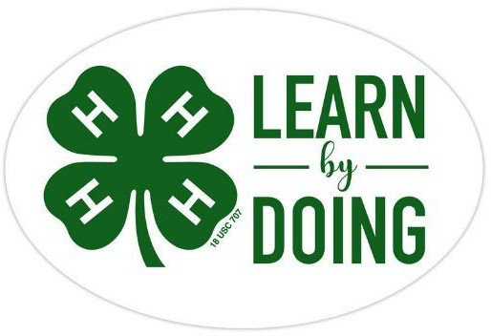
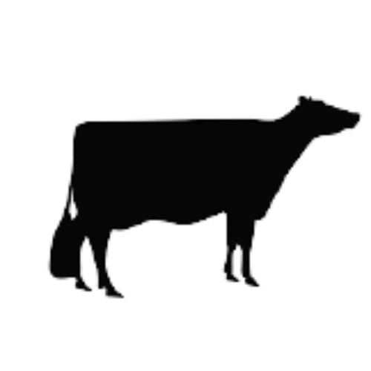
Name

Dairy 4-H

Club

CCEDC is an employer and educator recognized for valuing AA/EEO, Protected Veterans, and Individuals with Disabilities and provides equal program and employment opportunities. The programs provided by this agency are partially funded by monies received from the County of Dutchess. Please contact the CCEDC office if you have any special needs.

*pages modified from Oceana County 4-H in Michigan and Michigan State University Extension with permission.

PROJECT OBJECTIVES
The purpose of the project is to help 4-H Club members to:

- Gain an understanding of the work put into the daily care of the dairy cow as well as the preparation required for showing.
- To develop a sense of responsibility through acts of community service.
- To make lifelong friends, practice good sportsmanship, develop organizational and planning skills, all while having fun in a safe environment.
- To enable the youth to become educated enough about the industry to be able to initiate the much needed conversation from farmer to consumer.

REQUIREMENTS
- Be a member of a 4-H Dairy Club and attend meetings regularly, or engage in an Independent Dairy Project with the 4-H office.
- Follow the leadership of the project leaders and Extension Staff.
- Conduct a Dairy project.
- Complete a County Level Public Presentation, participate in Community Service, and keep an accurate and up to date record book for each area of participation.

Why Keep Records?
  - Members learn more about their project animals- costs, feed, health &
management skills.
  - Document activities and progress in the project.
  - Improve management and production practices.
  - Helps plan future projects.

Dairy Project Summary
Have you participated in other dairy activities, fairs, clinics, etc.: Yes No If yes, list the activities, shows, fair or related programs attended:

What are your goals for this year’s dairy project?

Showmanship: (list 1 quality of a good show person)

What were 2 ways you helped or taught others this year (4-H is about helping others as well as bettering yourself):

PARTS OF A DAIRY COW
(WRITE THE NAME OF THE PART NEXT TO THE CORRECT NUMBER BELOW)
*Courtesy OSU Dairy Learning Laboratory Kit
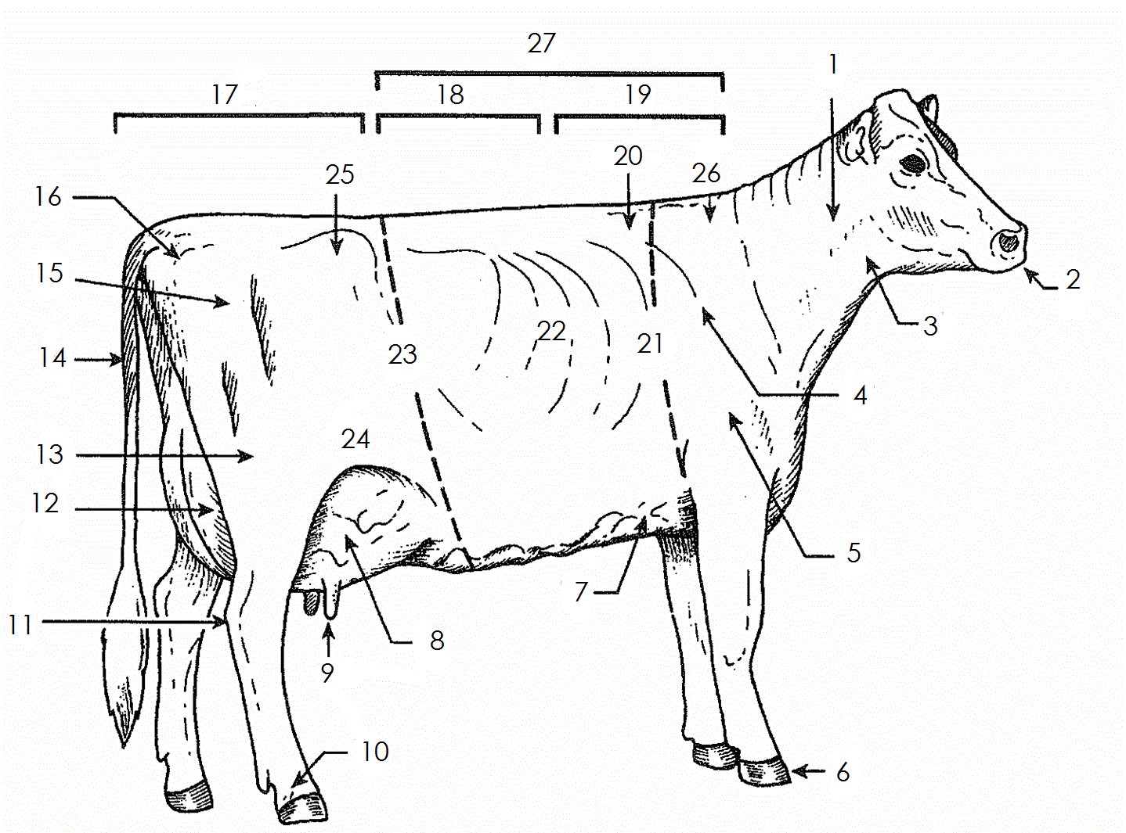
WORD BANK
RIBS CHINE
CHEST FLOOR BARREL
CROPS
FORE UDDER HEART GIRTH HIP (HOOKS) HOOF
HOCK LOIN NECK MUZZLE PASTERN
PIN BONE
POINT OF SHOULDER REAR UDDER
BACK RUMP
SHOULDER BLADE STIFLE
THIGH TEAT TTAIL
THROAT THURL
WITHER

1. | 2. | 3.
4. | 5. | 6.
7. | 8. | 9.
10. 11. |  | 12.
13. 14. |  | 15.
16. 17. |  | 18.
19. 20. |  |  | 21.
22. 23. |  |  | 24.
25. 26. |  |  | 27.

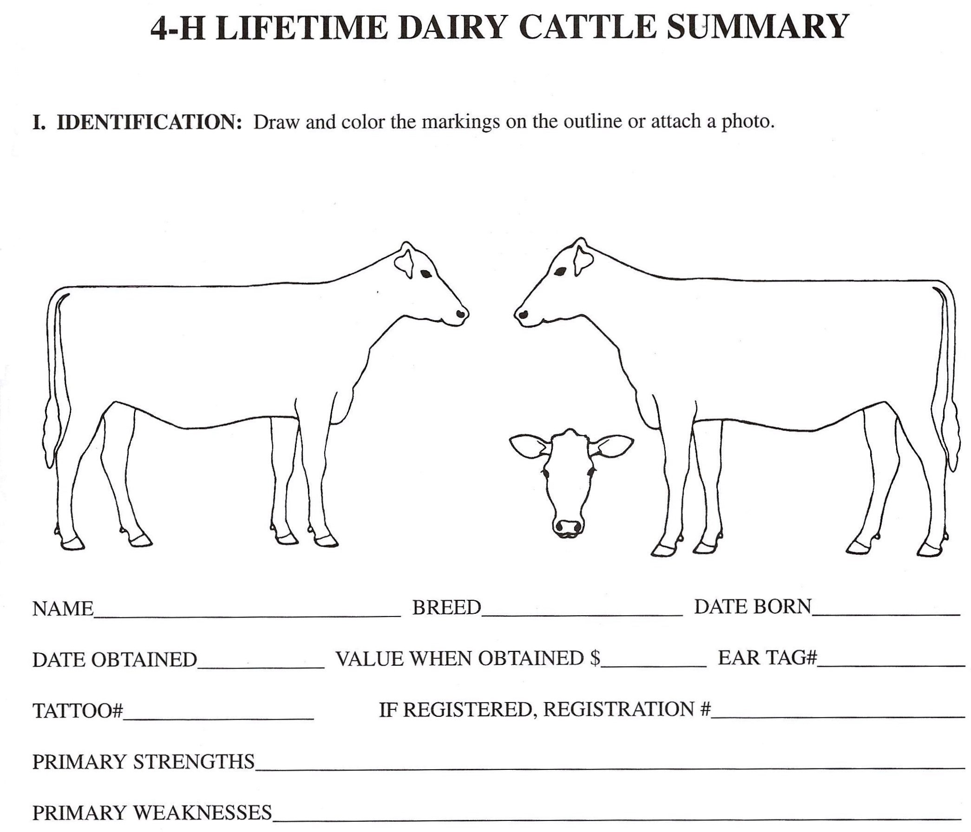
IDENTIFICATION: Draw and color the markings on the outline or attach a photo of at least 1 of your 4-H dairy cattle projects.
Answer the questions below using the same project animal.

Primary Strengths or Best Features:

Primary Weaknesses or Worse Features:

Management Records

Name: | Breed:
Date of Birth or Age: | RFID (required)

- How often do you feed/water your project?
- What does your animal’s feed consist of?
- Do you give your animals any supplements? If so what?
- What type of bedding do you use for your dairy project?
- If your dairy project is milked, what is the milking procedure from beginning to end?
- How often do you clean the pen/barn your animal stays in? How do you do this?

Dairy ANIMAL Record of Care

Animal(s) Name/I.D.#

** It will be assumed that you walked & fed your animal, but what additional things have you done such as; washed, clipped, trimmed, foot care, health practices, medicines, halter breaking, training, had vaccinated, etc. **

Starting Date of Week | Care Given | Care Giver

Dairy FARM Work Record
Record all of the work you completed for the farm that your dairy project is raised on. For example: What are your responsibilities besides taking care of your 4-H dairy animal?

Date(s) | Description of Work Completed | Number of Hours Spent  On Task
- If your animal(s) being raised on your own property, please have your parent or guardian sign acknowledging that you provided the care to the animal(s) and completed the dairy work as recorded.
- If you are borrowing an animal from someone else, have the owner sign acknowledging
that you provided the care to the animal(s) & completed the dairy farm work as recorded.

I, , do attest and certify that this 4-Her cared for this animal
Property Owner’s Name-or Parent if raised on own Farm (please print)
in a responsible manner while housed on my property and completed the works/tasks listed above. I also understand that integrity and responsibility are important to the 4-H experience.

Signature of Property Owner Date
Or Parent if raised on own Farm

Records Questionnaire
(Questions refer to the farm or herd where your cow/heifer is regularly housed, ask questions
of the farm owner if you do not know the answers).
What breed(s) of cattle does the farm have? How many lactating cows does the farm have? How many dry cows does the farm have? Total number of heifers and calves on the farm? At what age are calves weaned off milk at this farm? Is the herd on a dairy testing program? If yes, which program is it
on?

QUIZ BOWL QUESTIONS

- Name 3 internal parasites of dairy cows: ,

, .

- What are 4 of the 6 major nutrients found in feedstuffs? ,

, ,

- What are the 2 main gases produced in the rumen? ,

- Name 4 types of bedding typically used for dairy cattle: ,

, ,

- Name 3 ways a dairy cow excretes (or loses) water : ,

,

- A healthy cows body temperatures should be: .

SENIORS ONLY- 4-H Age 14+
Dairy Cow Unified Score Card
Using the Dairy Cow Unified Score Card (updated 2009 and can be found at: http:// www.purebreddairycattle.com/pages/Literature.php ), list the criteria under each of the FOUR major traits. This is what you would use to choose your show animal.
- Frame—15%
Example: RUMP– 5 points

- Dairy Strength– 25%

- Rear Feet & Legs– 20%

- Udder– 40%

DAIRY KNOWLEDGE
What is a pedigree and what information is usually found in a pedigree for a dairy animal?

How old should a calf be before it is weaned? Describe the housing and environment your animal was raised in.

Describe the grain ration(s) you used and list the main ingredients in each.

It is especially important to provide clean, fresh water at all times as milk is % water.

TRIVIA

Which dairy breed generally has the highest level of milk production?

What is the common name for the disease traumatic gastritis?

An inflammation or infection of the mammary gland is called?

Cattle have 4 stomach compartments and are therefore called ruminants. Name them.

, ,

, .
Which stomach compartment is referred to as the true stomach?

List 5 major dairy breeds: , ,

, , .

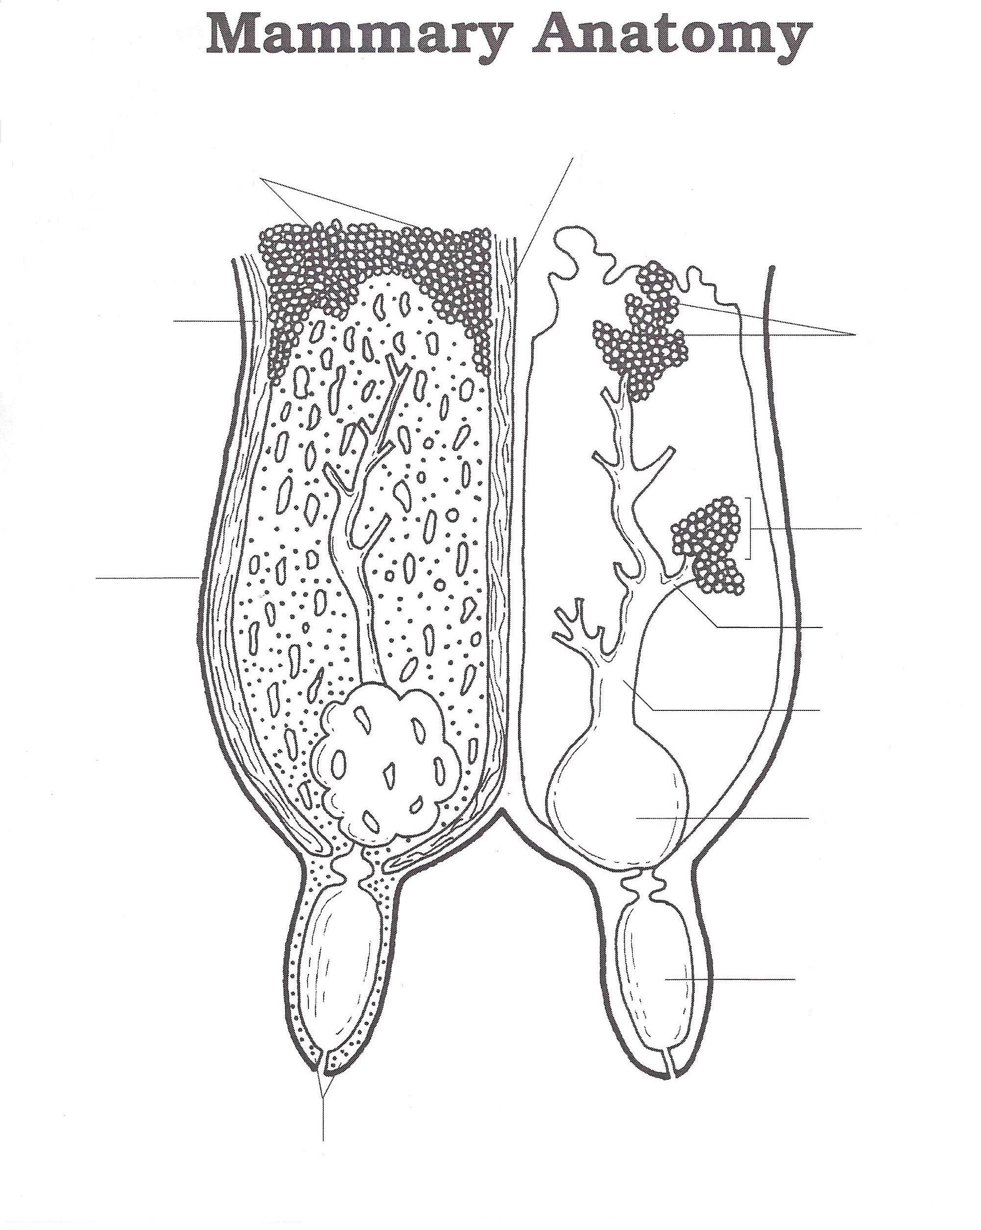

WRITE THE CORRECT NAME OF THE PART ON THE LINE IN THE ABOVE DIAGRAM

Alveolar duct | Gland cistern | Skin
Alveoli | Lateral suspensory ligament | Sphincter muscle
Collecting duct | Lobule | Teat cavity
Fat | Medial suspensory ligament

Dairy Project Photos
1. Be creative. The more photos, the better! You are encouraged to be in the photo with your Dairy project animal(s).
- You should also include the date of your photograph by, or on it.
- Captions also help the judge understand what the picture represents.

YEAR IN REVIEW
Specific to your project, answer the following questions. Please add drawings, pictures, diagrams or newspaper clippings.

What were your goal(s) for this year?

Did you achieve them? Explain why or why not.

What was your greatest accomplishment this year?

What do you want to work on or learn about next year?

Year in Review continued
Use this space to add additional feedback on your project this year.

Summary of Club Meetings attended in the current 4-H Year
This record is of business meetings and educational activities done as a club. It does not include special events such as countywide events, field trips, shows, the fair, etc.

Club Name: Club Leader(s)

Club meetings attended this year | # Meetings held  by Club | # Meetings you  attended | % Meetings  you attended | # Hours you  attended
A minimum of 6 meetings per year is required by all clubs. What percentage attendance is required by your club?
%

Summary and Declaration

Those youth completing all 4-H expectations will be deemed as being in “GOOD STANDING” for the current 4-H year. This is an accomplishment to be proud of and will be rewarded with a Certificate and 4-H Achievement Pin.

Complete the table below to be eligible for this award by checking the box to certify you fulfilled each expectation.

4-H Expectations to complete the 4-H Year in GOOD STANDING | State YES if you completed  this
Enrolled in 4-H by May 31 of the current 4-H year
Always abided by the 4-H Code of Conduct
Attended at least the minimum number of meetings required by my club(s)
Met all 4-H and Club deadlines on time
Completed a County-level Public Presentation
Submitted MY 4-H Story in the correct format on time
Submitted my completed Project Record Book on time
I hereby declare that this 4-H Record Book, which contains: Section 1: My Personal Development Record; and Section 2: My Project(s) Record(s)
is a true record of my activities/accomplishments from the current 4-H year.

I confirm that, so far as is reasonably possible given my age and abilities, it is my own work.
Signed by 4-H’er: Signed by Club Leader:

