**Section 2: Project Record**

Dairy Cloverbud



*Name*

*Club*



*CCEDC is an employer and educator recognized for valuing AA/EEO, Protected Veterans, and Individuals with* Disabilities and provides equal program and employment opportunities. The programs provided by this agency are partially funded by monies received from the County of Dutchess. Please contact the CCEDC office if you have any special needs.

**ABOUT ME**

Name: __________________________________________________

4-H Age: ___________________ Years in 4-H: _________________

Club: ___________________________________________________

4-H Project Year: _________________________________________

*Draw/paste a picture of yourself and/or your heifer below:*

**ABOUT MY HEIFER**

The breed of my heifer is: ___________________________________

Her registered name Is:_____________________________________

Her registration number is:___________________________________

Her ear tag number is:______________________________________

My heifer was born on: _____________________________________

I got my heifer on: _______________________________________

I bought my heifer or sponsored her from: ______________________

________________________________________________________

My heifer’s dam is: ________________________________________

My heifer’s sire is: _________________________________________

**HEALTH, NUTRITION AND MANAGEMENT**

I feed my heifer:___________________________________________

I give my heifer _____________________________________to drink

My heifer eats ________________________ pounds of grain per day

My heifer eats __________________________ pounds of hay per day

My heifer weighs about _____________pounds on ______________

My heifer lives in:_________________________________________

Things I like about my heifer are: _____________________________

________________________________________________________

Draw a picture of where your heifer lives, including her ban/shed, field, feed and water troughs, and any other details you want to include

 **WRITE A SHORT STORY ABOUT YOUR HEIFER!**

Tell us about what she likes and dislikes, things you do together her friends, and other fun facts

________________________________________________________________

________________________________________________________________

________________________________________________________________

________________________________________________________________

________________________________________________________________

________________________________________________________________

________________________________________________________________

________________________________________________________________

Paste a picture(s) of your heifer below from August. It could be of the Fair!

**COSTS FOR MY PROJECT**

In the table below, give us a list of all the things that had to be purchased for your project this year. This can include things such as how much your heifer cost to but, her feed, her equipment, veterinary fees, your show clothes and anything else you can think of.

|  |  |
| --- | --- |
| The Item I Needed for my Project | The person who bough it of gave it to you |
|  |  |
|  |  |
|  |  |
|  |  |
|  |  |
|  |  |
|  |  |
|  |  |

My parents and/or Club Leader helped me estimate that my project costs this year came to a total of:

$

 **BREED IDENTIFICATION**

Put the name of the breed in the blank below each picture:

Holstein Ayrshire Jersey

Guernsey Brown Swiss Milking Shorthorn

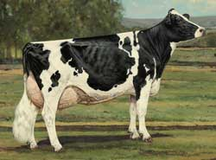 [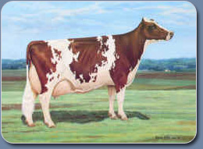](http://www.usayrshire.com/Images/Ideal%20Ayrshire%20Cow.jpg)

_____________________________________ _____________________________________

[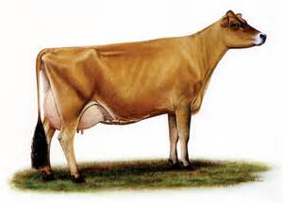](http://www.bing.com/images/search?q=jersey+cattle+association&view=detailv2&&id=077D8414CF88CBDBE76F8BD517B1671889509A21&selectedIndex=0&ccid=Esm4DdbO&simid=608045431551364076&thid=OIP.M12c9b80dd6cef54e99d0166e0c8485bco0) [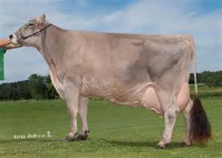](http://www.bing.com/images/search?q=brown+swiss+cattle+association&view=detailv2&&id=C3C3A60A34FAB66B6C729C2B1D46F4D6641D37D0&selectedIndex=0&ccid=u0aNiXRb&simid=608026035481544054&thid=OIP.Mbb468d89745bb1040663330f67531969o0)

_____________________________________ _____________________________________

](http://www.bing.com/images/search?q=guernsey+cattle+breed+standard&view=detailv2&&id=CB1082EE74142089BE0CF8AA19649627569B65CE&selectedIndex=23&ccid=nIU6MNjs&simid=608039680589826464&thid=OIP.M9c853a30d8eca2444355d25980f7a1abo0) A horse with a horse head

_____________________________________ ______________________________________

**Club Meeting Summary Cloverbud**

**What you did in your Club this 4-H Year**

Club Name:

**How many meetings did your club hold this year**

**How many meetings did you attend this year**

**Tell us one thing you really enjoyed about 4-H this year**

**Tell us three things you learned this year through 4-H**

**Summary and Declaration**

Those youth completing all 4-H expectations will be deemed as being in “GOOD STANDING” for the current 4-H year. This is an accomplishment to be proud of and will be rewarded with a Certificate and 4-H Achievement Pin.

Complete the table below to be eligible for this award by checking the box to certify you fulfilled each expectation.

|  |  |
| --- | --- |
| 4-H Expectations to complete the 4-H Year in  GOOD STANDING | State YES if you completed this |
| Enrolled in 4-H by May 31 of the current 4-H year |  |
| Always abided by the 4-H Code of Conduct |  |
| Attended at least the minimum number of meetings required by my club(s) |  |
| Met all 4-H and Club deadlines on time |  |
| Completed a County-level Public Presentation |  |
| Submitted MY 4-H Story in the correct format on time |  |
| Submitted my completed Project Record Book on time |  |

I hereby declare that this 4-H Record Book, which contains:

Section 1: My Personal Development Record; and

Section 2: My Project(s) Record(s)

is a true record of my activities/accomplishments from the current 4-H year.

I confirm that, so far as is reasonably possible given my age and abilities, it is my own work.

**Signed by 4-H’er:**

**Signed by Club Leader:**