Section 2: Project Record
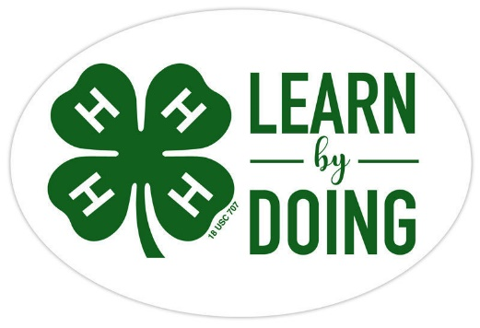

Entomology
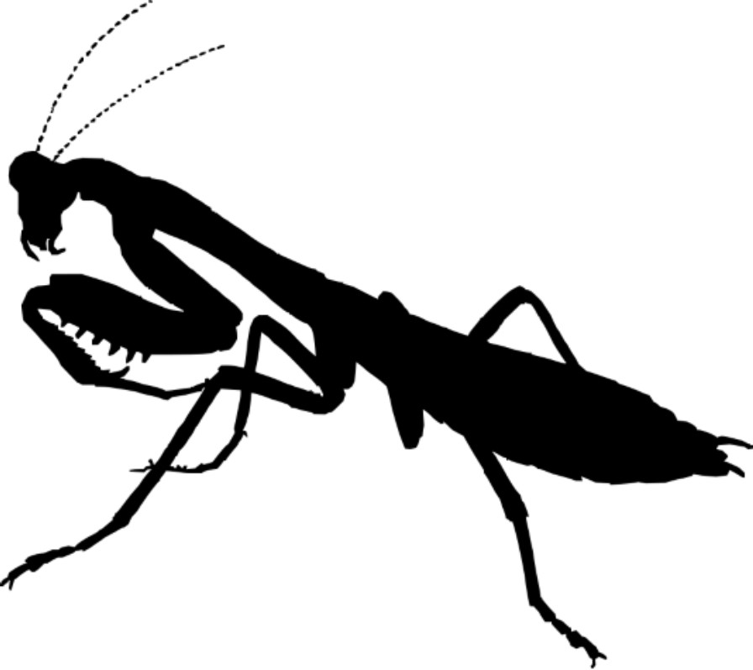

Name

Club

CCEDC is an employer and educator recognized for valuing AA/EEO, Protected Veterans, and Individuals with Disabilities and provides equal program and employment opportunities. The programs provided by this agency are partially funded by monies received from the County of Dutchess. Please contact the CCEDC office if you have any special needs.

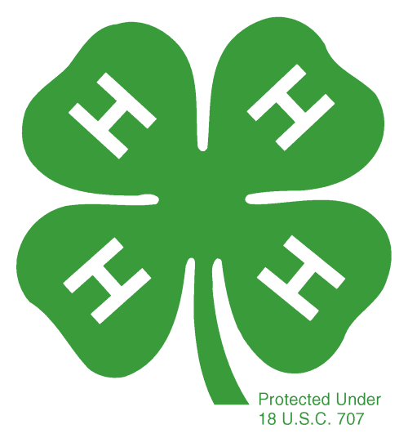
PROJECT INFORMATION
PROJECT OBJECTIVES:
The purpose of the project is to help 4-H Club members to:
1. Acquire life skills through project participation and apply those skills to become an active, skilled, responsible community member.
2. Develop leadership skills that promote positive youth development.
3. To work on record keeping, planning, communication and organization skills.
4. To organize and participate in community service projects as leaders as well as members of a team.
5. Keep abreast of the latest practices and research findings in their project area.
6. Familiarize youth with entomology and herpetology by research and experimentation.
7. To understand the relationships that exist between species specifically humans and the creatures in the entomology and herpetology. To use their projects to inform their club and communities of the importance of these relationships.
REQUIREMENTS:
1. Be an Independent Member or a member of a 4-H club and attend meetings regularly.
2. Follow the leadership of the project leaders and Extension Staff.
3. Conduct an approved entomology and/or herpetology project.
4. Complete a County Level Public Presentation, participate in Community Service and keep an accurate and up to date record book for each area of participation.
4-H ENTOMOLOGY/HERPETOLOGY PROGRAM
Please copy these two pages and use for each separate project you do.

NAME OF PROJECT:

___________________________________________________________________________

Please attach a photo or draw a picture of your project in the box below. Additional schematics can be attached or added by inserting extra pages.

Please explain your project. Tell what it is and briefly describe the steps you took to make it.

What was the easiest part of your project?

What was the hardest part of your project?

Tell us some things you learned from doing your project.

INVENTORY
An inventory is a list of items, materials, or tools that have been purchased before the current year – the things you already have.

ITEM DESCRIPTION | COST

TOTAL INVENTORY VALUE:_________________

FINANCIAL SUMMARY
Under expenses, list the items/supplies/materials you have
purchased in this 4-H year in order to complete your project(s)
EXPENSES
Date  Purchased | Type of Expense  Describe what you purchased | Cost per Item | # Items Purchased | Total  Cost
Total

INCOME
Date | Type of Income | Amount
Total

PROFIT OR LOSS
Income $______________ minus Expenses $ ______________ = $ ______________

This 4-H year, I made a PROFIT LOSS (circle one)
YEAR IN REVIEW
Specific to your project, answer the following questions. Please add drawings, pictures, diagrams, or newspaper clippings.

What were your goal(s) for this year?

Did you achieve them? Explain why or why not.

What was your greatest accomplishment this year?

What do you want to work on or learn about next year?

Year in Review continued
Use this space to add additional feedback on your project this year.

Summary of Club Meetings attended in the current 4-H Year
This record is of business meetings and educational activities done as a club. It does not include special events such as countywide events, field trips, shows, the fair, etc.

Club Name:

Club Leader(s)

Club meetings attended this year | # Meetings held by Club | # Meetings you attended | % Meetings you attended | # Hours you attended
A minimum of 6 meetings per year is required by all clubs. What percentage attendance is required
by your club?
%

Summary and Declaration

Those youth completing all 4-H expectations will be deemed as being in “GOOD STANDING” for the current 4-H year. This is an accomplishment to be proud of and will be rewarded with a Certificate and 4-H Achievement Pin.

Complete the table below to be eligible for this award by checking the box to certify you fulfilled each expectation.

4-H Expectations to complete the 4-H Year in  GOOD STANDING | State YES if you completed this

Enrolled in 4-H by May 31 of the current 4-H year

Always abided by the 4-H Code of Conduct

Attended at least the minimum number of meetings required by my club(s)

Met all 4-H and Club deadlines on time

Completed a County-level Public Presentation

Submitted MY 4-H Story in the correct format on time

Submitted my completed Project Record Book on time

I hereby declare that this 4-H Record Book, which contains:
Section 1: My Personal Development Record; and
Section 2: My Project(s) Record(s)
is a true record of my activities/accomplishments from the current 4-H year.

I confirm that, so far as is reasonably possible given my age and abilities, it is my own work.

Signed by 4-H’er:

Signed by Club Leader:

