How to Access the 4-H Membership Directory
Go to https://ccedc.wildapricot.org
Log into your account by clicking the “Log in” button.
*Note that you must be logged into your LEADER account (if you have children in 4-H, you will not be able to access the membership directory through their account)
Once logged in, select the “Membership Directory” Tab.
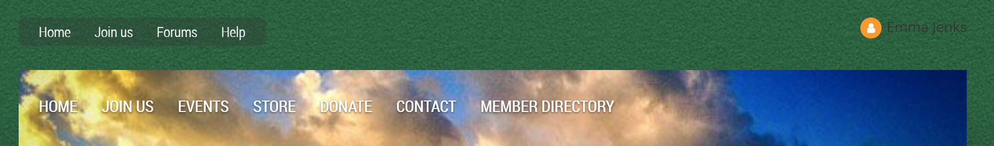
Select the name of your club or enter the name of a specific youth.
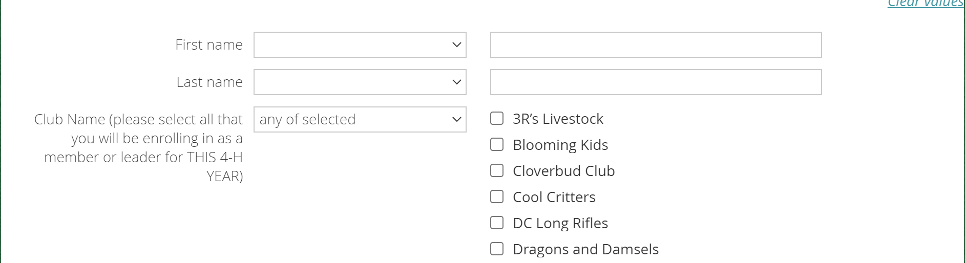
Once you have selected your club, click the “Search” button. This will bring up all the members (including leaders) currently enrolled in the club selected. (click name for more info)
