Section 2: Project Record
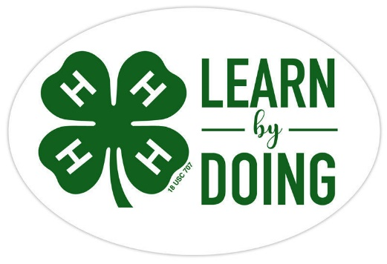

Model Horse
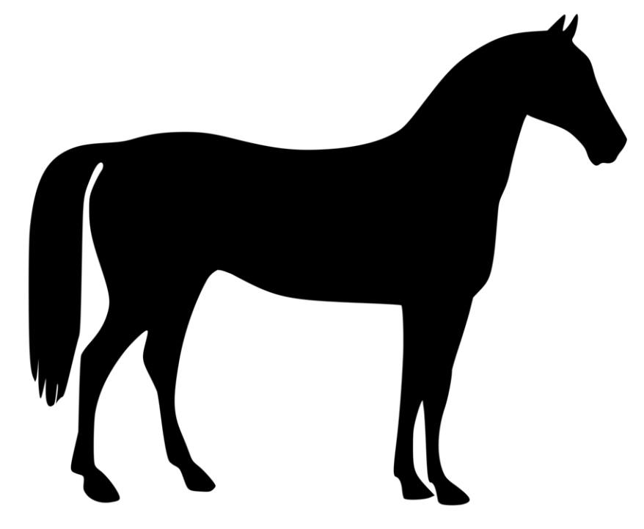
Name

Club

CCEDC is an employer and educator recognized for valuing AA/EEO, Protected Veterans, and Individuals with Disabilities and provides equal program and employment opportunities. The programs provided by this agency are partially funded by monies received from the County of Dutchess. Please contact the CCEDC office if you have any special needs.

PROJECT OBJECTIVES:
The purpose of the project is to help 4-H Club members to:
1. Build confidence and promote sportsmanship through model horse showing.
2. Gain knowledge of real horses through model horse showing and other planned activities.
3. Encourage creative minds and hands through model horse activities.
REQUIREMENTS:
1. Be a member of a 4-H club and attend meetings regularly or an Independent member.
2. Must attend either the Model Horse Clinic, Annual Model Horse Show, or both.
3. Follow the leadership of the project leaders and extension staff.
4. Complete a County Level Public Presentation, participate in Community Service, assist with the Model Horse events as needed, and keep an accurate and up to date record book.
DUTCHESS COUNTY 4-H
MODEL HORSE PROGRAM

MODEL HORSE PROJECT INVENTORY

Herd Record - Start of Project Year (Do not include horses purchased this year)
For each horse in your herd at the start of the project year, write down the name you gave it, the manufacturer’s model name or mold number if you know it, the breed that you have decided it best represents, the age/sex (abbreviations are S = stallion, G = gelding, M = mare), the color, the finish (OF =original finish or RRH = remade/repaint/haired) and the estimated value (purchase price or appraised value). If you have a large herd, you need not record each model. However, you should record all the models that you enter in any show. You may add additional sheets if needed.

HORSE NAME | MANUFACTURER’S |  | YEAR ACQUIRED | BREED | AGE/SEX | COLOR | FINISH | VALUE
 | MODEL # | NAME
Sub Total of this sheet (copy to next sheet)
HORSE NAME | MANUFACTURER’S |  | YEAR ACQUIRED | BREED | AGE/SEX | COLOR | FINISH | VALUE
 | MODEL # | NAME
Sub Total of this sheet
Sub Total from previous sheet
TOTAL VALUE OF INVENTORY AT THE BEGINNING OF THE YEAR
Tack and Accessories Inventory - Start of Project Year (Do not include items purchased this year)
List in the appropriate section, all the tack you own at the start of the project year. Include a description of the item, which horse or horses the item can be used with (examples: any Classic, traditional, saddlebred, stock breeds, etc.), and the manufacturer, if known. Be sure to check whether you purchased the item or whether you made it yourself. If you own a lot of tack and accessories, you need not record each one. However, you should record all the items that you use in any shows. You may add additional sheets if needed.

ITEM | CHECK ONE |  | YEAR ACQUIRED | DESCRIPTION | MANUFACTURER | COST | VALUE
 | PURCH-ASED | SELF-MADE
TOTAL VALUE OF TACK AND ACCESSORIES AT THE BEGINNING OF THE YEAR

SHOW and ACTIVITY RECORDS
EVENT | DATE | MODEL NAME/# AND CLASS | Trophy/Award/Place

In the space below, please highlight things you have learned by participating in shows, clinics, etc.

PROJECT EXPENSES
Please record all expenses for your project for this program year. This may include horses, purchases of props and supplies, show entries, etc.

Date | Item | Cost
TOTAL

PROJECT CREATION
Please record all items made for your models during this program year.

Date | Item | Time Spent | Cost
TOTAL

PROJECT INCOME
Please record all income for your project, which may be none! This may include sales or show premiums for example.

Date | Item | Cost
TOTAL:

PROJECT FINANCIAL SUMMARY
Please determine if you made money or lost money on your project. Don’t worry if you didn’t make a profit, the idea is to learn what the activity cost is and develop good record keeping skills!

Total Expenses = $

Total Income = $

Income – Expenses $

Check One: Profit Loss

PROJECT PHOTOS
Include photos of your projects or Model Horse events from this year below!

Club Meeting Summary
What you did in your Club this 4-H Year
Club Name:

How many meetings did your club hold this year
How many meetings did you attend this year

Tell us one thing you really enjoyed about 4-H this year

Tell us three things you learned this year through 4-H

Summary and Declaration

Those youth completing all 4-H expectations will be deemed as being in “GOOD STANDING” for the current 4-H year. This is an accomplishment to be proud of and will be rewarded with a Certificate and 4-H Achievement Pin.

Complete the table below to be eligible for this award by checking the box to certify you fulfilled each expectation.
4-H Expectations to complete the 4-H Year in  GOOD STANDING | State YES if you completed this

Enrolled in 4-H by May 31 of the current 4-H year

Always abided by the 4-H Code of Conduct

Attended at least the minimum number of meetings required by my club(s)

Met all 4-H and Club deadlines on time

Completed a County-level Public Presentation

Submitted MY 4-H Story in the correct format on time

Submitted my completed Project Record Book on time

I hereby declare that this 4-H Record Book, which contains:
- Section 1: My Personal Development Record
- Section 2: My Project(s) Record(s)

This is a true record of my activities/accomplishments from the current 4-H year. I confirm that, so far as is reasonably possible given my age and abilities, it is my own work.

Signed by 4-H’er:

Signed by Club Leader:

